ITSE 1302

Travis Doporto

Lesson 3 Assignment

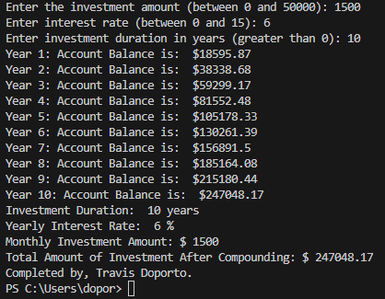

investment_amount = int(input("Enter the investment amount (between 0 and 50000): "))

while investment_amount < 0 or investment_amount > 50000:

    print("Investment amount invalid.")

    investment_amount = int(input("Enter the investment amount (between 0 and 50000): "))

interest_rate = int(input("Enter interest rate (between 0 and 15): "))

while interest_rate < 0 or interest_rate > 15:

    print("Interest rate invalid")

    interest_rate =int(input("Enter interest rate (between 0 and 15): "))

investment_duration = int(input("Enter investment duration in years (greater than 0): "))

while investment_duration < 0:

    print("Investment duration invalid.")

    investment_duration = int(input("Enter investment duration in years (greater than 0): "))

total_balance = 0

monthly_rate = interest_rate / 12 /100

months = investment_duration * 12

for month in range(1, months+1):

    total_balance = total_balance + investment_amount

    total_balance = (monthly_rate * total_balance) + total_balance

    total_balance = round(total_balance, 2)

    if month % 12 == 0:

        print(f"Year {month // 12}: Account Balance is:  ${round(total_balance, 2)}")

print(f"Investment Duration: ", investment_duration, "years")

print(f"Yearly Interest Rate: ", interest_rate, "%")

print(f"Monthly Investment Amount: $", investment_amount)

print(f"Total Amount of Investment After Compounding: $", total_balance)

print("Completed by, Travis Doporto.")